SALARY PREDICTION APP

MINI PROJECT REPORT
OF INTERNSHIP

BACHELOR OF TECHNOLOGY
COMPUTER SCIENCE AND
ENGINEERING

Submited To


Dr. A.P.J. ABDUL KALAM TECHNICAL UNIVERSITY
LUCKNOW

SUBMITTED BY
VISHAL TIWARI
University Roll No. 2200100100390

Assistant Professor UNITED COLLEGE OF ENGINEERING & RESEARCH, PRAYAGRAJ, 2025-26

Title Page:

1. Name of Student: VISHAL TIWARI
2. AKTU Roll No: 2200100100390
3. E-mail: vishaltiwari7086@gmail.com, Phone No. : 7607002535
4. Branch: Computer Science and Engineering
5.Batch: 7 B1
6. Proposed Topic: Salary Prediction App

CANDIDATE’S DECLARATION

I, VISHAL TIWARI (2200100100390), students of B.Tech of Computer Science and Engineering hereby declared that I own the full responsibility for the information, results etc provided in this mini project titled “Salary Prediction App” submitted to Dr. A.P.J Abdul Kalam Technical University, Lucknow for award of B.Tech (COMPUTER SCIENCE AND ENGINEERING) degree. I have taken care in all respect to honour the intellectual property right and have acknowledged the contributions of others for using them in this academic purpose. I further declared that in case of any violation of intellectual property right or copyright, I as the candidate would be fully responsible for the same. My supervisor and institute should not be held for full or partial violation of copyright if found at any stage of our degree.

Date: 07/11/2025
VISHAL TIWARI
Place: United College of Engineering and Research
(2200100100390)

ACKNOWLEDGEMENT

I, VISHAL TIWARI (2200100100390) am grateful to the management of United College of Engineering & Research for providing me an opportunity to undertake my internship on the topic “Salary Prediction App” . I am grateful and thankful to the faculties and all the other senior staff of the college, as they have helped me in every way possible. They put me under good supervision which helped in learning a lot of new things about the project and its various applications. They also provided me all the necessary information needed. I must make special mention of our H.O.D. Dr. Vijay Kumar Dwivedi, for providing me a platform to complete my mini project successfully. I would thank all the lab maintenance staff for providing assistance in various H/W & S/W problem encountered during course of my project. I am also very thankful to respected principal sir who gave me an opportunity to present this project.

INTRODUCTION

In today’s data-driven world, predicting employee salaries accurately has become an important application of Artificial Intelligence and Machine Learning. Traditional methods of salary estimation often rely on static job data and fail to consider multiple dynamic factors such as education, experience, job title, industry, company size, and location. To overcome these limitations, our project — AI-Based Salary Prediction App — aims to design a system capable of predicting an employee’s estimated salary using regression-based machine learning models.

The main goal of this project is to help both employers and job seekers gain better insights into salary trends. Employers can benchmark compensation more effectively, while job seekers can evaluate their market worth based on skills, experience, and educational qualifications.

The proposed system uses a dataset named salary_train.csv, which contains real-world salary data with features like education level, experience (in years), job title, industry, company size, and location. The data is preprocessed using techniques such as handling missing values, encoding categorical variables, and scaling numerical features to ensure high-quality input for the machine learning model.

To build the predictive model, the system employs ensemble learning algorithms — specifically, Random Forest Regressor and Gradient Boosting Regressor — combined through a Voting Regressor for improved performance and reliability. These algorithms help capture non-linear relationships between features and salary outcomes, ensuring robust prediction accuracy.

The trained model is then integrated into a user-friendly Graphical User Interface (GUI) using Tkinter, allowing users to input personal and professional details and instantly receive a predicted salary output. The entire model is serialized using Pickle (.pkl), enabling easy reuse and deployment without retraining.

The system not only showcases the practical use of AI in human resource analytics but also demonstrates how data science can automate complex business decisions with minimal human intervention. By predicting salaries based on multiple parameters, this application provides transparency, data-backed insights, and a scalable tool for the modern workforce.

In summary, the AI-Based Salary Prediction App combines data preprocessing, advanced machine learning models, and a real-time GUI interface to deliver an intelligent, interactive, and accessible salary forecasting solution.

FEASIBILITY STUDY

The feasibility of the proposed Salary Prediction App has been evaluated from multiple perspectives:

1. Technical Feasibility:
The system is developed using widely available open-source libraries like Python, Pandas, Scikit-Learn, and Tkinter. It can run smoothly on any standard computer with Python installed, requiring minimal computational power. Hence, the technical feasibility is high.

2. Operational Feasibility:
The application offers an easy-to-use GUI that does not require prior technical knowledge. Users simply enter input details and get instant results, making it operationally practical and efficient.

3. Economic Feasibility:
All tools and technologies used are open-source, eliminating the need for licensing or paid software. The project development cost is limited to time and effort, ensuring high economic viability.

4. Time Feasibility:
The project can be completed within a short duration (4–6 weeks), including stages of dataset preparation, model training, testing, GUI design, and documentation.

Thus, the proposed system is technically achievable, cost-effective, user-friendly, and time-efficient.

METHODOLOGY / PLANNING OF WORK

The project is executed in several well-defined phases:
Step 1: Data Collection
Used the dataset salary_train.csv containing relevant features like education, experience, job title, location, and salary.
Step 2: Data Preprocessing
Handled missing data using SimpleImputer, scaled numeric attributes with StandardScaler, and converted categorical data using OneHotEncoder.
Step 3: Model Development
Implemented Random Forest and Gradient Boosting Regressors and combined them through a Voting Regressor for enhanced prediction accuracy.
Step 4: Model Evaluation
Tested on 20% unseen data, achieving an MAE of ₹6,436.73 and an R² score of 0.6991 (≈70% accuracy).
Step 5: GUI Integration
Created a user interface with Tkinter to allow real-time prediction. Inputs include education, experience, job title, company size, etc.
Step 6: Model Deployment
The trained model is saved as pbel_project.pkl and integrated for reuse in the GUI without retraining.
This systematic approach ensures high accuracy, usability, and reproducibility of results.

Facilities required for proposed work

Hardware Requirements:
- Processor: Intel i5 or higher
- RAM: Minimum 8 GB
- Storage: 500 GB HDD or higher
- Operating System: Windows 10 / 11 or equivalent

Software Requirements:
- Programming Language: Python (v3.8 or higher)
- Libraries: Pandas, Scikit-Learn, Tkinter, Pickle, NumPy
- IDE: Jupyter Notebook / VS Code / PyCharm
- Dataset: salary_train.csv

Other Resources:
- Internet connection for library installation and research
- Visualization and documentation tools (MS PowerPoint, Excel, etc.)
The required resources are minimal and easily accessible, ensuring smooth execution of the project from development to deployment.

DFD:

LEVEL-0

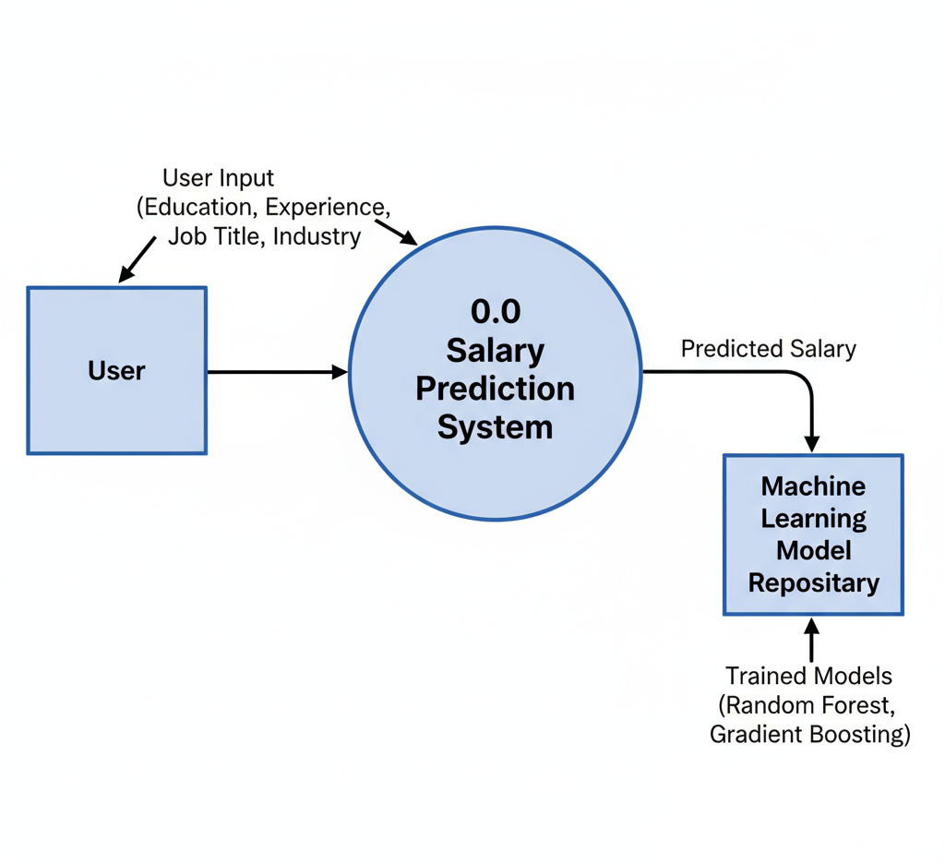

LEVEL-1
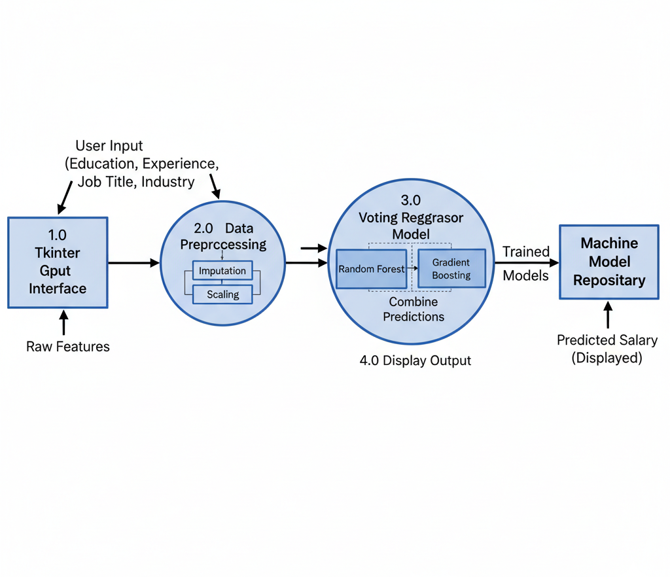

Results / Snapshots

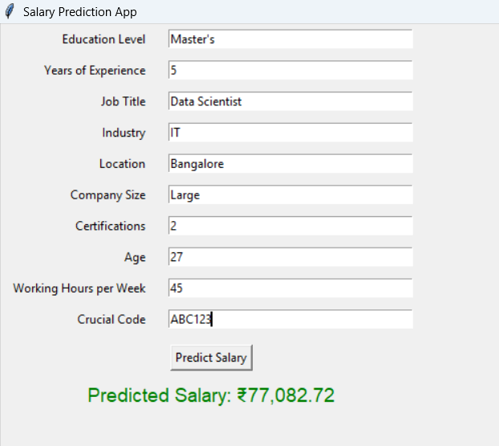

REFERENCES

- Scikit-Learn Documentation — https://scikit-learn.org
- Pandas Library — https://pandas.pydata.org
- Tkinter GUI Documentation — https://docs.python.org/3/library/tkinter.html
- Dataset Source — Custom/Academic salary dataset (salary_train.csv)
- Ensemble Learning Techniques — Research papers and tutorials on Random Forest, Gradient Boosting, and Voting Regressor
- Medium & Kaggle Articles on Salary Prediction and ML Regression Projects

